**Module 7) JQuery Basic, Effects & Advanced**

**1.What is jQuery?**

Ans:-

* jQuery is a fast and lightweight JavaScript library designed to simplify HTML document traversal and animation interactions
* jQuery is a fast, small, and feature-rich JavaScript library. It simplifies things like HTML.
* jQuery is designed to be easy to use and allows developers to write less code to achieve common tasks.
* Ex:-

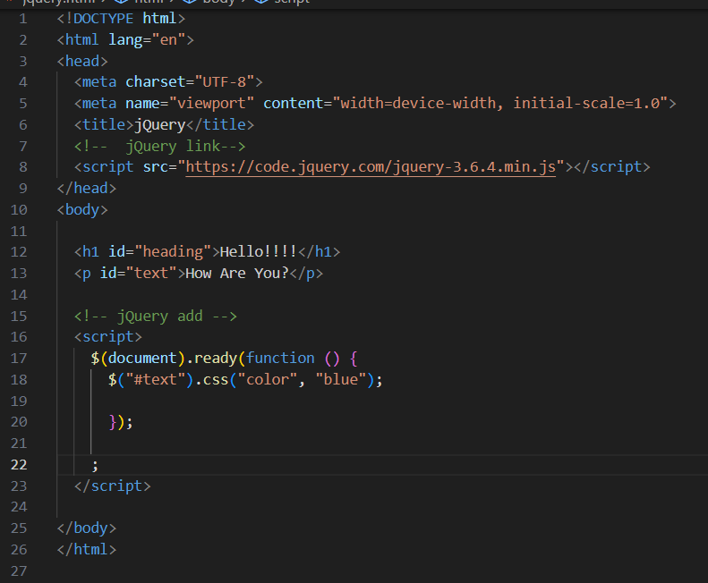

Output:--

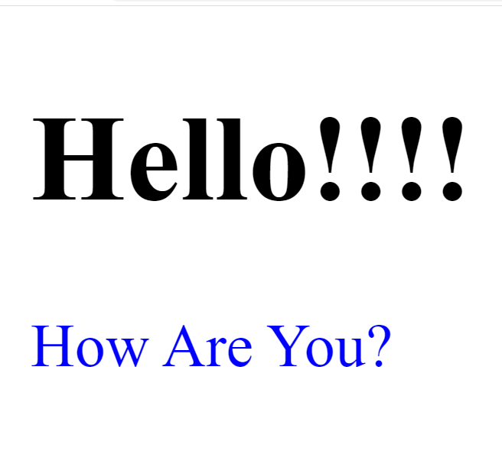

**2. How to Apply CSS Using JQuery, How to Add Class and Remove Class in Jquery, JQuery Animation?**

**1.Apply CSS Using JQuery**

Ans:-

* use jQuery to apply CSS styles to elements.

Ex:-

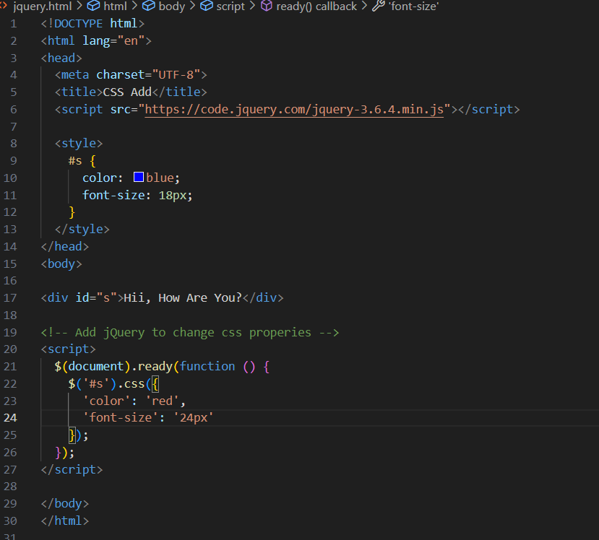

Output:-

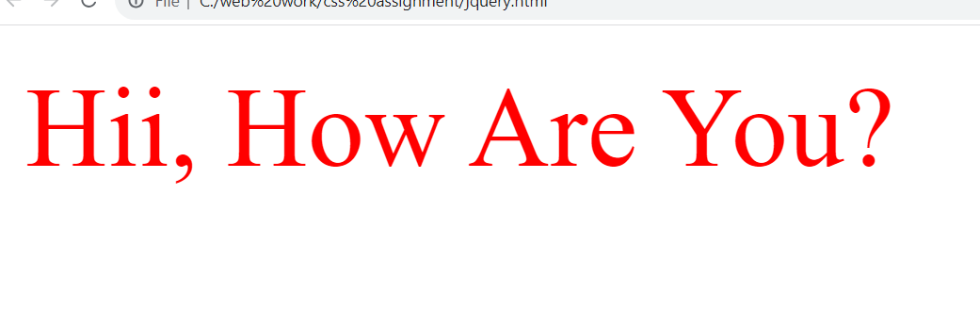

2.Adding and Removing Classes:-

* add and remove classes using jQuery:

Ex:-

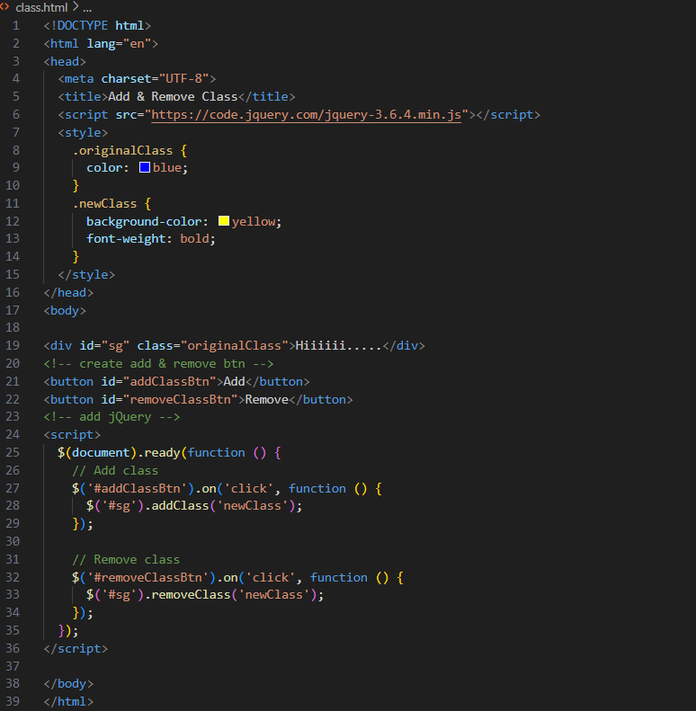

Output:-

Original Class:-

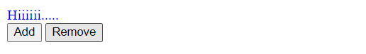

Add Class:-

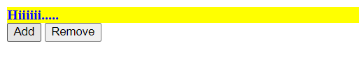

Remove Class:-



3. JQuery Animation:-

* jQuery provides a simple and effective way to create animations on web pages. Here's a basic example of a jQuery animation

Ex:

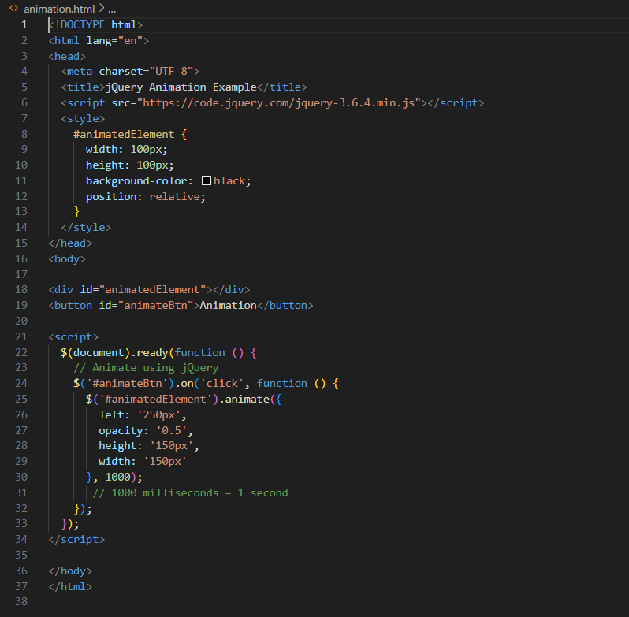

**3. How to create slider with animation?**

Ans:-

* Creating a slider with animation typically involves using HTML, CSS, and JavaScript. Here's a simple example using HTML, CSS, and JavaScript to create a basic slider with animation.

Ex:-

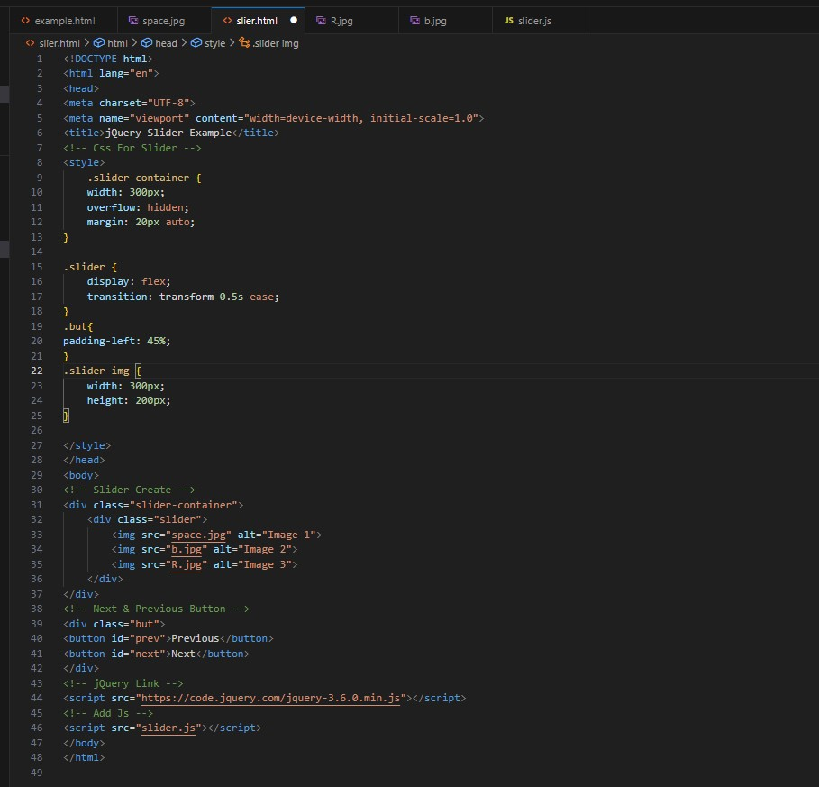

Output:-

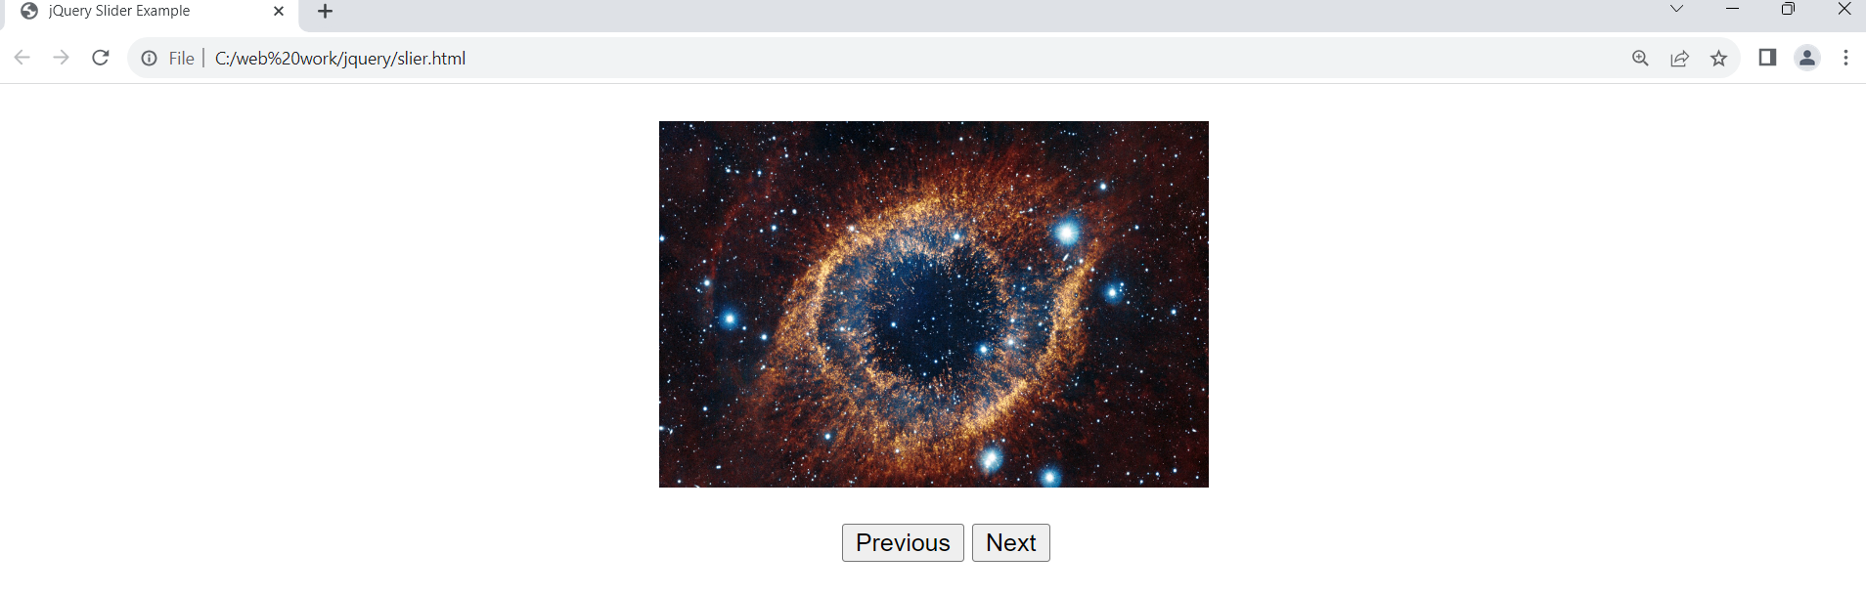

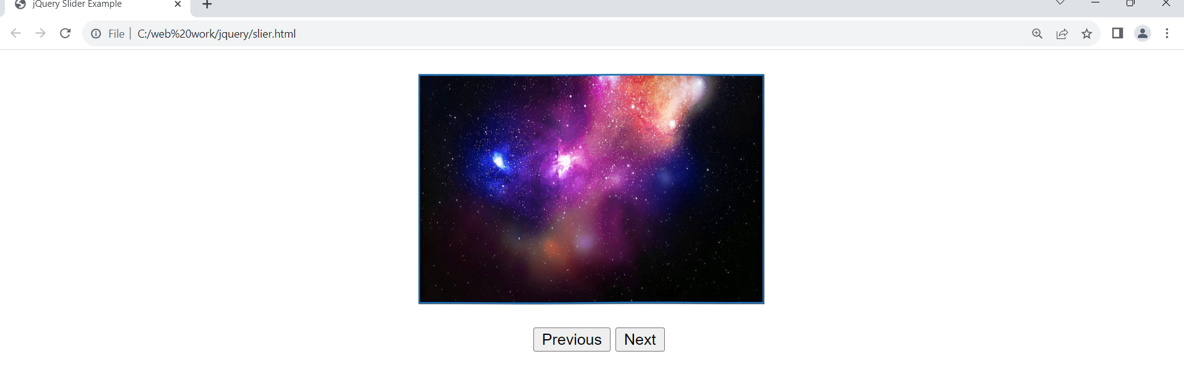

• Event bubbling tickling example